SPRING CREEK WATERSHED COMMISSION
Regular Member Meeting

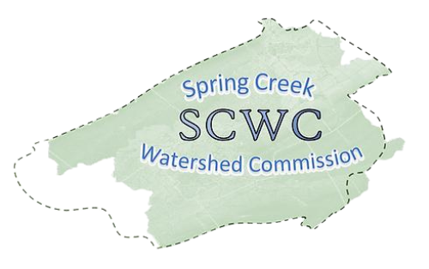
Wednesday, November 19, 2025,
6:30 PM to 8:30 pm
College Township Main Meeting Room (2nd Floor)
1481 E. College Ave, State College, PA 16801
Zoom Link:
https://us06web.zoom.us/j/89272152245?pwd=fUevNZ5Tg0y0frnPbDx2A74ffIyG7j.1
Meeting ID: 892 7215 2245
Passcode: 117650

- Call to Order: Chair Brachbill will call the meeting to order
Note that our Member Meetings will start at 6:30pm ending at 7:30pm followed by an Educational Presentation starting at 7:30pm ending at 8:30pm.
- Roll Call and Introductions: Establish which Municipalities are present and recognize their representatives (Elected/Alternate).

- Public Comment & Written Correspondence:
The public is invited to address Commission items not listed on the agenda. (Limit 5 min. per person). Electronic copies of comments may be submitted to SCWC and will be added to the meeting minutes.
- Review & Approval of Previous Meeting Minutes:
Meeting Minutes from September 17th, 2025. Call for a motion and a 2nd to discuss the minutes as needed, followed by a vote of the Member Meeting.

- New Agenda Items: At this time, any members wishing to add items to the agenda are requested to do so.

- Report on Officers and Committees:
  - Vice-Chair Standing Committee Report – Bob Igo
  - Finance Report – Approval of Bills – Kevin Abbey
  - Atlas Report– Jon Eaton
  - Member At Large Report – Jasmine Fields
  - Watershed Coordinator Report – Elyse Johnson
  - AmeriCorps Member Report – Deb Escalet

- Old Business:
  - SCWC Strategy Meetings (meeting with each member municipality)
  - SCWC Stormwater Workgroup
  - Grants Committee

8) New Business:
- Spring Creek Cleanup 11/23 10AM - 3PM Click here to Register
- Stroud Water Research Center’s Salt Snapshot
- State College Climate Action, Resiliency, and Environmental Sustainability Plan Input Click here to take survey

- Relevant water-related news from member Municipalities:

- Educational Topic: Introduction by Elyse Johnson
Caitlin Glagola (PA Senior Watershed Planner) and Mariah Saunders (Halfmoon Conservation Coordinator) from the Chesapeake Bay Foundation will share information about conservation efforts in the Halfmoon Watershed, the EPA Section 319 Nonpoint Source Management Program, and Watershed Implementation Plans.
10) Matters of Record:
- See SCWC Event Calendar for details and future postings.
- SCWC Annual Reorganization Meeting 1/21 6:30-8:30 PM Location TBD
- Atlas Project 11/20, 12/18 1-3 PM Patton Township
- Conservation & Stewardship Committee 12/2 3:00-4:00 Willowbank Building
- Authorities Committee Meeting 12/4 1:30-2:30 301 N Spring St.

11) Adjournment – Motion to approve followed by Second

