SPRING CREEK WATERSHED COMMISSION
Regular Member Meeting

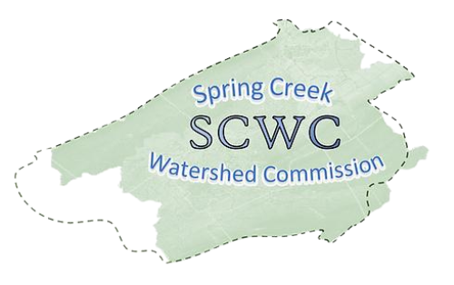
Wednesday, January 21, 2026,
6:00 PM to 8:00 pm
Patton Township Board Room
100 Patton Plaza, State College, PA 16803
Zoom Link:
https://us06web.zoom.us/j/89272152245?pwd=fUevNZ5Tg0y0frnPbDx2A74ffIyG7j.1
Meeting ID: 892 7215 2245
Passcode: 117650

- Call to Order: Chair Brachbill will call the meeting to order
Note that our Member Meetings will start at 6:30pm ending at 7:30pm followed by an Educational Presentation starting at 7:30pm ending at 8:30pm.
- Roll Call: Establish which Municipalities are present and recognize their representatives (Elected/Alternate).

- Public Comment & Written Correspondence:
The public is invited to address Commission items not listed on the agenda. (Limit 5 min. per person). Electronic copies of comments may be submitted to SCWC and will be added to the meeting minutes.
- Review & Approval of Previous Meeting Minutes:
Meeting Minutes from September 17th, 2025. Call for a motion and a 2nd to discuss the minutes as needed, followed by a vote of the Member Meeting.

- New Agenda Items: At this time, any members wishing to add items to the agenda are requested to do so.

- Election of Officers

- Introduction of 2026 Representatives

- Report on Officers and Committees:
  - Vice-Chair Standing Committee Report
  - Treasurer’s Report – Approval of Bills
  - Watershed Coordinator Report – Elyse Johnson
  - AmeriCorps Member Report – Deb Escalet
  - Atlas Committee Updates
  - Conservation & Stewardship Committee Updates
  - Governments Committee Updates
  - Authorities Committees Updates

- Old Business
  - 11/23/25 Spring Creek Cleanup with Trout Unlimited Outcomes
  - Set date for 3rd Annual State of the Watershed Event

- New Business
  - Stormwater Workgroup’s Tudek Park Regenerative Stormwater Project
  - Public Project Viewer GIS Mapping Project Updates
  - 4/18/26 Watershed Cleanup Day

- Relevant water-related news from member municipalities

- Educational Topic: On-boarding and overview of the Spring Creek Watershed Commission’s history – Kevin Abbey

10) Matters of Record:
- See SCWC Event Calendar for details and future postings.
- Next SCWC Regular Meeting 3/18/26
- Atlas Committee Meetings 2/19, 3/19 1:00-3:00 PM, Patton Township
- Conservation & Stewardship Committee 2/10, 3/ 3:00-4:00, Willowbank Building
- Authorities Committee Meeting 2/12 1:30-2:30 301 N Spring St.

11) Adjournment – Motion to approve followed by Second

