SPRING CREEK WATERSHED COMMISSION
Regular Member Meeting

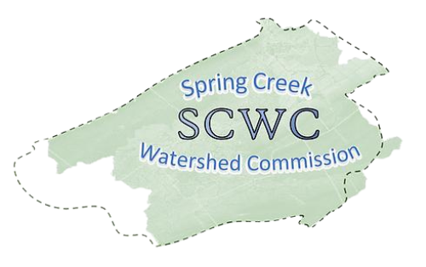
Wednesday, September 17, 2025,
6:30 PM to 8:30 pm
College Township Main Meeting Room (2nd Floor)
1481 E. College Ave, State College, PA 16801
Zoom Link: https://us06web.zoom.us/j/89272152245?pwd=fUevNZ5Tg0y0frnPbDx2A74ffIyG7j.1
Meeting ID: 892 7215 2245
Passcode: 117650

- Call to Order: Chair Brachbill will call the meeting to order
Note that our Member Meetings will start at 6:30pm ending at 7:30pm followed by an Educational Presentation starting at 7:30pm ending at 8:30pm.
- Roll Call and Introductions: Establish which Municipalities are present and recognize their representatives (Elected/Alternate).

- Public Comment & Written Correspondence:
The public is invited to address Commission items not listed on the agenda. (Limit 5 min. per person). Electronic copies of comments may be submitted to SCWC and will be added to the meeting minutes.
- Review & Approval of Previous Meeting Minutes:
Meeting Minutes from July 16th, 2025. Call for a motion and a 2nd to discuss the minutes as needed, followed by a vote of the Member Meeting.

- New Agenda Items: At this time, any members wishing to add items to the agenda are requested to do so.

- Report on Officers and Committees:
  - Vice-Chair Standing Committee Report – Bob Igo
  - Finance Report – Approval of Bills – Kevin Abbey
  - Atlas Report– Jon Eaton
  - Member At Large Report – Jasmine Fields
  - Watershed Coordinator Report – Elyse Johnson
  - AmeriCorps Member Report – Deb Escalet

- Old Business:
  - SCWC Strategy Meetings - stakeholder engagement, fundraising,
  - Meeting with each member municipality
  - SCWC Stormwater Workgroup
  - Grants Committee
  - State of the Watershed Roundtable postponed to Q4

8) New Business:
- Milesburgh Borough membership

- Relevant water-related news from member Municipalities:

- Educational Topic: Introduction by Elyse Johnson
Tracey Olexa, University Stormwater Engineer, will share an update on Penn State Office of the Physical Plant’s stormwater projects and initiatives.
10) Matters of Record:
- See SCWC Event Calendar for details and future postings.
- SCWC Regular Meeting 11/19 6:30-8:30 PM Location TBD
- Governments Committee 10/16 11-12 College Twp Board Room
- Atlas Project 9/18, 10/23 1-3 PM Patton Township
- Conservation & Stewardship Committee 10/9 3-4:30 Willowbank Building

11) Adjournment – Motion to approve followed by Second

