SPRING CREEK WATERSHED COMMISSION
Regular Member Meeting

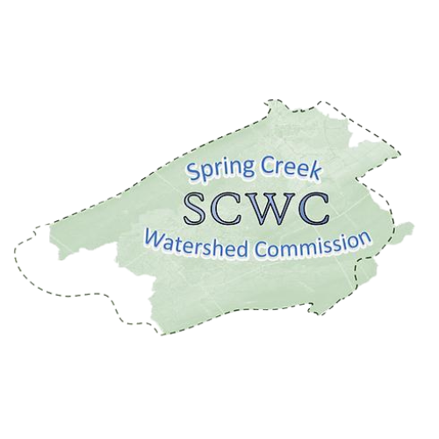
Wednesday, May 21, 2025,
6:30 PM to 8:30 pm
1481 E. College Ave, State College, Pa. 16801
1st Floor Library (inside main office)
Zoom Link: https://us06web.zoom.us/j/87617364261?pwd=NIA5WVgZ89K77aVBkznMO3Tc1xFwgx.1
Meeting ID: 876 1736 4261
Passcode: 059014

- Call to Order: Chair Brachbill will call the meeting to order
Note that our Member Meetings will start at 6:30pm and end at 7:30pm followed by Educational Presentation starting at 7:30 pm ending at 8:30pm.
- Roll Call and Introductions: Establish which Municipalities are present and recognize their representatives (Elected/Alternate).

- Public Comment & Written Correspondence:
The public is invited to address Commission items not listed on the agenda. (Limit 5 min. per person). Electronic copies of comments may be submitted to SCWC and will be added to the meeting minutes.
- Review & Approval of Previous Meeting Minutes:
Meeting Minutes from March 19, 2025. Call for a motion and a 2nd to discuss the minutes as needed, followed by a vote of the Member Meeting.

- New Agenda Items: At this time any members wishing to add items to the agenda are requested to do so.

- Report on Officers and Committees:
  - Vice-Chair Standing Committee Reports – Bob Igo
  - Finance Reports – Approval of Bills – Kevin Abbey
  - Atlas – Jon Eaton
  - Educational Report – Jasmine Fields
  - AmeriCorps – Elyse Johnson & Caitlin Dooley

- Old Business:
  - Motion/2nd to appoint David Roberts for SCWC Secretary
  - Motion/2nd to Rename and Refocus on the Educational Committee to the Speakers Committee
  - SCWC Coordinating Committee 2025 plan. Vice-Chair, Bob Igo
  - Communication and Outreach to facilitate focus and distribute workload to committees. Motion/2nd required
  - 2nd Annual State of the Watershed Event 3/27/25 – Elyse Johnson
  - Watershed Congress 3/29/25 – Doug Mason and Barbara Fisher

8) New Business:
  - Stormwater Workgroup
  - SCWC Strategy Meeting in June
  - Member’s discussion – The Federal Government removed AmeriCorps funding this past week. Discussion among members on SCWC subsequent action. Authorization to pursue Independent Contractor agreement with Elyse Johnson through end of her AmeriCorps term of service August 2, 2025.

- Relevant water-related news from member Municipalities:

- Educational Topic: Introduction by Elyse Johnson
Streamside Stewardship- Jillian Barsky, Clearwater Conservancy’s Streamside Projects Coordinator, will provide an overview of the riparian program, highlight ongoing projects, and share opportunities to get involved.
11) Matters of Record:
  - The next SCWC Regular Meeting is 7/16 from 6:30-8:30 PM
  - SCWC Authorities Committee 5/22 1:30-2:30 PM
    - Dave Jostenski from DEP will be presenting on the Statewide Water Plan and the Spring Creek Watershed
  - SCWC Conservation & Stewardship Committee 5/27 1:00-2:00 PM
  - See SCWC Event Calendar for details and future postings.

11) Adjournment – Motion to approve followed by Second

