SPRING CREEK WATERSHED COMMISSION
Regular Member Meeting

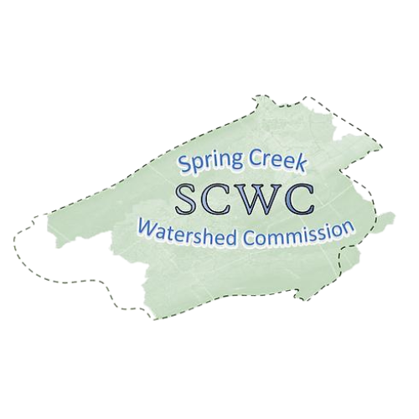
Wednesday, July 16, 2025,
6:30 PM to 8:30 pm
College Township Main Meeting Room (2nd Floor)
1481 E. College Ave, State College, PA 16801
Zoom Link: https://us06web.zoom.us/j/89272152245?pwd=fUevNZ5Tg0y0frnPbDx2A74ffIyG7j.1
Meeting ID: 892 7215 2245
Passcode: 117650

- Call to Order: Chair Brachbill will call the meeting to order
Note that our Member Meetings will start at 6:30pm ending at 7:30pm followed by an Educational Presentation starting at 7:30pm ending at 8:30pm.
- Roll Call and Introductions: Establish which Municipalities are present and recognize their representatives (Elected/Alternate).

- Public Comment & Written Correspondence:
The public is invited to address Commission items not listed on the agenda. (Limit 5 min. per person). Electronic copies of comments may be submitted to SCWC and will be added to the meeting minutes.
- Review & Approval of Previous Meeting Minutes:
Meeting Minutes from May 21st, 2025. Call for a motion and a 2nd to discuss the minutes as needed, followed by a vote of the Member Meeting.

- New Agenda Items: At this time, any members wishing to add items to the agenda are requested to do so.

- Report on Officers and Committees:
  - Vice-Chair Standing Committee Reports – Bob Igo
  - Finance Reports – Approval of Bills and 2026 Budget – Kevin Abbey
  - Atlas – Jon Eaton
  - Member At Large Report – Jasmine Fields
  - Watershed Coordinator – Elyse Johnson

- Old Business:
  - SCWC Strategy Meetings - Meet with each member municipality by Labor Day to communicate SCWC Stewardship Plan (Phase III implementation)
  - SCWC Stormwater Workgroup

8) New Business:
- Motion to approve State of the Watershed Roundtable on Thursday, September 25th from 12-4pm
- Conservation & Stewardship Committee Educational Sign Project
- Establishing a Grants Committee

- Relevant water-related news from member Municipalities:

- Educational Topic: Introduction by Elyse Johnson
Countywide Action Plan (CAP) and CAP Subaward Grant Program
Leigh Fehlman, Watershed Specialist at the Centre County Conservation District, will share an overview of the Countywide Action Plan’s priority initiatives, funding options, and project examples (conservation landscaping, stormwater, etc.).
https://centrecountypa.gov/2237/Countywide-Action-Plan
10) Matters of Record:
- See SCWC Event Calendar for details and future postings.
- SCWC Regular Meeting 9/17 6:30-8:30 PM Location TBD
- Governments Commmittee 7/17 11-12 College Twp Board Room
- Atlas Project 7/17 1-3PM ClearWater Conservancy
- Conservation & Stewardship Committee 7/29 3-4:30 Willowbank Building Room 144
- Atlas Project 1-3PM 7/17 at Clearwater; 8/21 Patton Township
- Authorities Committee 8/28 1:30-2:30 PM 301 N Spring St Bellefonte, PA Small Conference Room
11) Adjournment – Motion to approve followed by Second

